Mini-SOC in a Box
Week 2 | Wazuh and Suricata Watch LabShop
Prepared by Nazrin Aliyeva
Technical Implementation and Verification Report
Wazuh 4.14.8 • Suricata 7.0.3 • Ubuntu Server 24.04 • Windows 10

Contents
1. Executive summary and requirement coverage
2. Lab architecture and Week 2 scope
3. Task 1 — LabShop log decoder, detection and tuning
4. Task 2 — Linux, Windows and registry file integrity monitoring
5. Task 3 — Suricata network detection and Wazuh integration
6. Task 4 — Security configuration and vulnerability assessment
7. Task 5 — Backups, recoverability and documentation
8. Troubleshooting, analysis and limitations
9. Conclusion

Requirement coverage
Brief item | Coverage in this report
Task 1 | Custom source, decoder, L5/L10 rules, MITRE T1110, six-case test matrix, persistence
Task 2 | Six file events, registry, content diff, scheduled vs real-time timing, evidence settings
Task 3 | Single Suricata signature, EVE JSON, raised custom Wazuh rule, service/NAT/memory
Task 4 | Both SCA policies, two banner fixes, accepted risk, top three CVEs per endpoint
Task 5 | README-ready summary, restoration guide, change journal, VM snapshots

1. Executive summary and project objectives
Week 2 extended the operational three-VM Mini-SOC established in Week 1. The fictional LabShop environment gained a custom application-log decoder and correlation rules, Linux and Windows file integrity monitoring (FIM), monitored Windows registry values, a Suricata IDS signature, centralized Suricata alert handling, and security posture assessment through Wazuh SCA and vulnerability inventory.
Controlled tests verified custom failed-login detection and same-source-IP correlation, file additions/modifications/deletions on both endpoints, a scheduled registry checksum-change alert, and a network HTTP /admin probe visible as a higher-severity Wazuh alert. Two Ubuntu login-banner checks were remediated; one partition-hardening finding was intentionally left unchanged because of implementation risk and scope.

Key verified outcomes
Capability | Evidence-backed outcome
Custom log detection | LabShop source /var/log/labshop/app.log, fields action/dstuser/srcip, L5 100101, L10 100102 with frequency 5 / 60s / same_srcip.
File integrity monitoring | Realtime add/modify/delete on ubuntu-web and win-client; registry Status value change produced Wazuh rule 750.
Network detection | Suricata SID 1000001 matched HTTP /admin; Wazuh rule 100110 level 10 raised default 86601 level 3.
SCA | Ubuntu 112→121 passed, 125→116 failed, 42 N/A; Windows 117 passed, 302 failed, 5 N/A.
Recoverability | Configuration copies and w2-start/w2-done snapshots of all three powered-off VMs.

2. Lab architecture and Week 2 scope
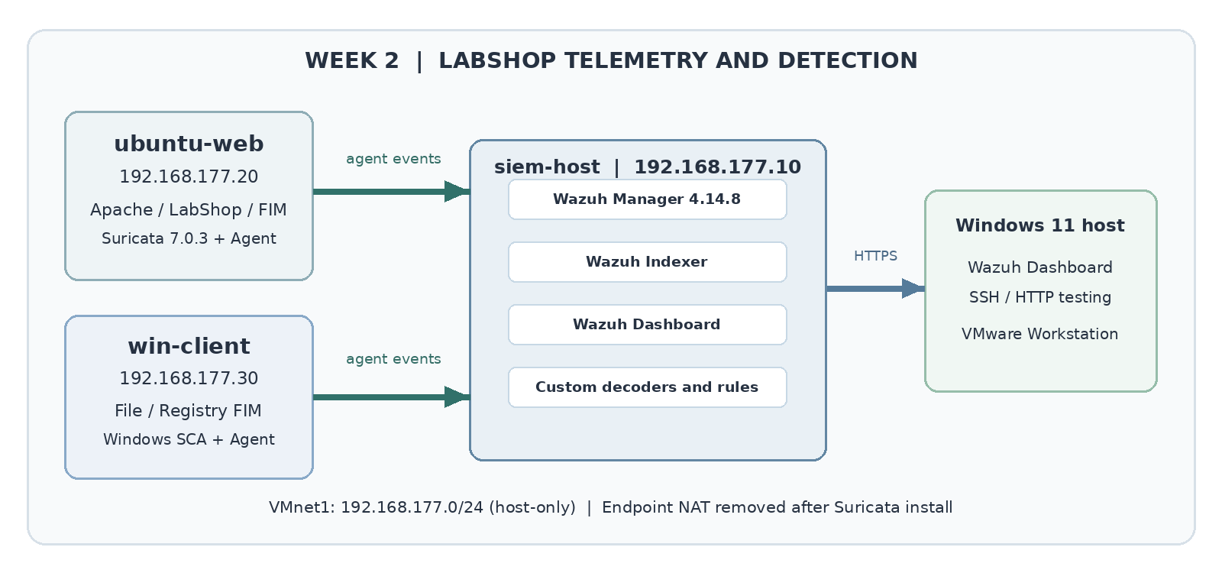
Figure 1. Week 2 detection architecture with endpoint log collection, FIM, Suricata and Wazuh rule evaluation.
System | Role and relevant configuration | Address / resource
siem-host | Wazuh 4.14.8 Manager, Indexer, Dashboard in single-node Docker Compose; custom decoders/rules | 192.168.177.10; 16 GB RAM / 6 vCPU
ubuntu-web | Apache, LabShop application log, Wazuh agent, real-time and scheduled FIM, Suricata IDS 7.0.3 | 192.168.177.20; 2 GB RAM / 2 vCPU
win-client | Wazuh agent and Sysmon; FIM on C:\LabShopData; scheduled HKLM LabShop registry monitoring | 192.168.177.30; 4 GB RAM / 2 vCPU

2.1 Network and event path
The VMware VMnet1 host-only subnet is 192.168.177.0/24. ubuntu-web temporarily received an ens34 NAT interface for installing Suricata; its final network state retained ens33 at 192.168.177.20/24 with only a connected host-only route and no default gateway. Suricata AF_PACKET captures on ens33. The local Windows 11 host initiates the HTTP probe from 192.168.177.1.
Application and endpoint data flow: source event → Wazuh agent → Manager decoder → Wazuh rule → alert document → Indexer → Dashboard. Suricata additionally inspects HTTP packets and writes structured EVE JSON; the agent forwards EVE records to the same Wazuh pipeline. This makes application and network signals independently searchable.

3. Task 1 — LabShop custom log detection

3.1 Source and custom decoder
The ubuntu-web agent reads /var/log/labshop/app.log as syslog. A parent decoder identifies the program labshop; its child decoder extracts the action (LOGIN_FAILED or LOGIN_OK), destination username (dstuser), and source IP (srcip). The custom decoder was stored as 100100-labshop_decoder.xml in the Manager custom decoder directory, separate from shipped Wazuh decoders.
Oct 23 12:45:01 ubuntu-web labshop[2521]: LOGIN_FAILED user=admin src=192.168.177.50
The screenshot-backed decoder test showed action=LOGIN_FAILED, dstuser=admin and srcip=192.168.177.50. A malformed source-IP token such as src=not-an-ip did not satisfy the child field extraction and did not trigger the LabShop custom rule.
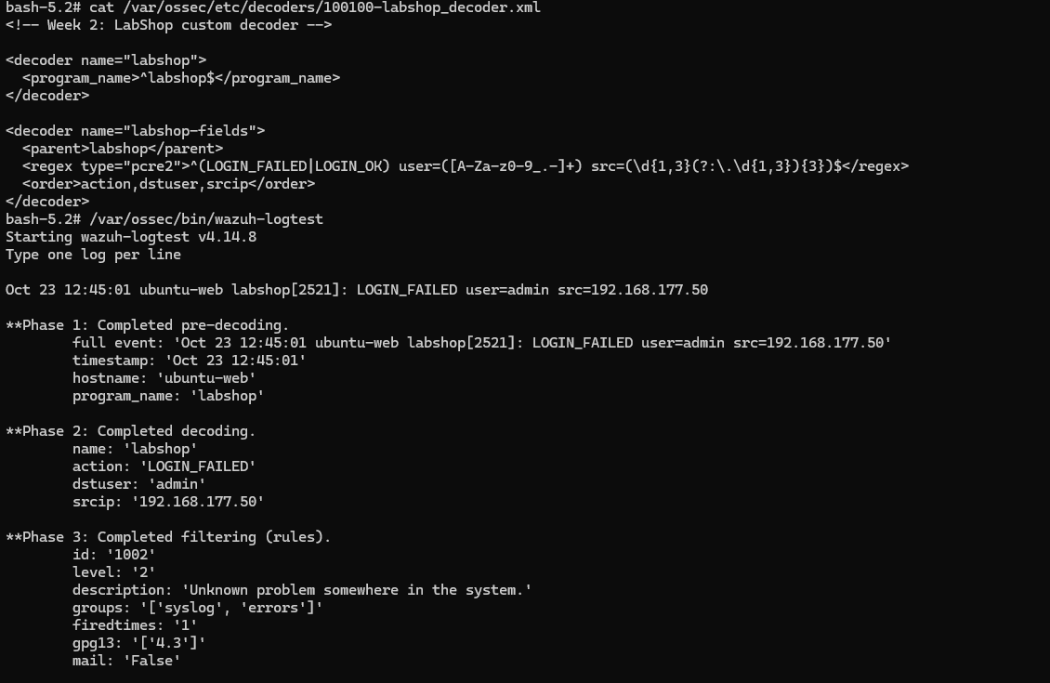
Figure 2. Parent/child LabShop decoder and a parsed LOGIN_FAILED sample in wazuh-logtest.

3.2 Custom rules and correlation
ID / level | Logic | Result
100101 / 5 | Match decoded LOGIN_FAILED; exclude expected monitor user; include srcip and dstuser. | Failed authentication alert, with health-check noise suppressed.
100102 / 10 | if_matched_sid=100101; frequency=5; timeframe=60; same_srcip; MITRE T1110. | Repeated failures from one IP raise a possible brute-force alert.
100110 / 10 | Suricata escalation on matching EVE signature 1000001. | See Task 3.

The correlation count uses Wazuh rule syntax and aggregates only events satisfying the same source-IP condition. Three failures from each of two IP addresses should not combine to satisfy a five-from-one-IP condition. The monitor user is deliberately excluded because its failed authentication is an expected health probe.
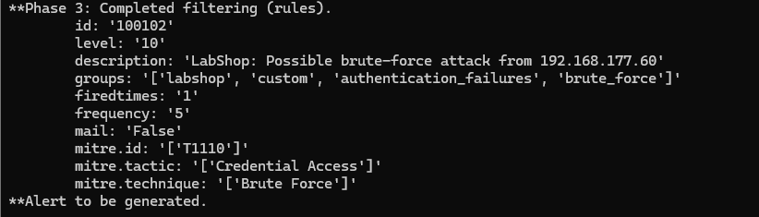
Figure 3. Wazuh Ruleset Test: rule 100102, level 10, five failures, MITRE ATT&CK T1110.
Validation and persistence. The Manager configuration was syntax-checked with wazuh-analysisd -t before reload; custom files were not inserted into shipped rule folders. The custom rules survived a Manager container restart through the persistent Compose-managed configuration. Backup copies of decoder/rule XML were retained on siem-host and their required Git paths are enumerated in Section 7.

3.3 Six-case validation and negative controls
The six-case matrix serves as the README-ready record.
Case | Expected | Ruleset Test / observed | Dashboard record
One LOGIN_FAILED | 100101 L5 | 100101 L5 observed | LabShop failure events seen; separate one-event image
Six failures; same IP | 100101 then 100102 L10 | 100102 L10 with frequency=5, srcip=192.168.177.60 | Custom alerts observed; see earlier Task 1 evidence
3 + 3 failures; two IPs | Individual L5, no 100102 | L5 on changing IP; same-IP correlation not met | No cross-IP L10 expected
monitor failure | Suppress 100101/100102 | Fallback 1002 L2 observed; no custom alert | No custom alert expected
LOGIN_OK | No failed-login rule | No custom L5/L10 expected | No failed-login alert expected
Malformed line | No child decoder / custom rule | Fallback 1002 L2 for src=not-an-ip | No custom alert expected

4. Task 2 — File and registry integrity monitoring

4.1 Monitored paths and operating modes
Endpoint | Target | Configuration / mode
ubuntu-web | /var/www/html | Realtime FIM, report_changes=yes; preserves text diffs
ubuntu-web | /etc/w2-fim-scheduled.conf | Scheduled FIM, temporary 120-second test interval; reverted to 43200 seconds
win-client | C:\LabShopData | Realtime FIM, report_changes=yes
win-client | HKLM\SOFTWARE\LabShop (Status value) | Scheduled registry monitoring, 64-bit view, report_changes=yes
The Wazuh syscheck module created checksums for monitored objects. For text modifications it also recorded before/after SHA-256 and a content diff. Registry changes are monitored on scheduled scans rather than as instantaneous registry notifications; a temporary scan-frequency change was used to verify the Status value and then restored.

4.2 Event validation — both operating systems
Event | Ubuntu rule / level | Windows rule / level
New file | 554 / 5 | 554 / 5
Modified file | 550 / 7 | 550 / 7
Deleted file | 553 / 7 | 553 / 7
Registry Status changed | Not applicable | 750 / 5
Linux test file: /var/www/html/w2-fim-test.txt. Windows test file: C:\LabShopData\w2-fim-test.txt. Both progressed through added → modified → deleted. Content changes increased the Linux test size from 29 to 58 bytes and the Windows test size from 30 to 60 bytes. Wazuh showed the appended text “LabShop FIM test - version 2” in its diff fields.
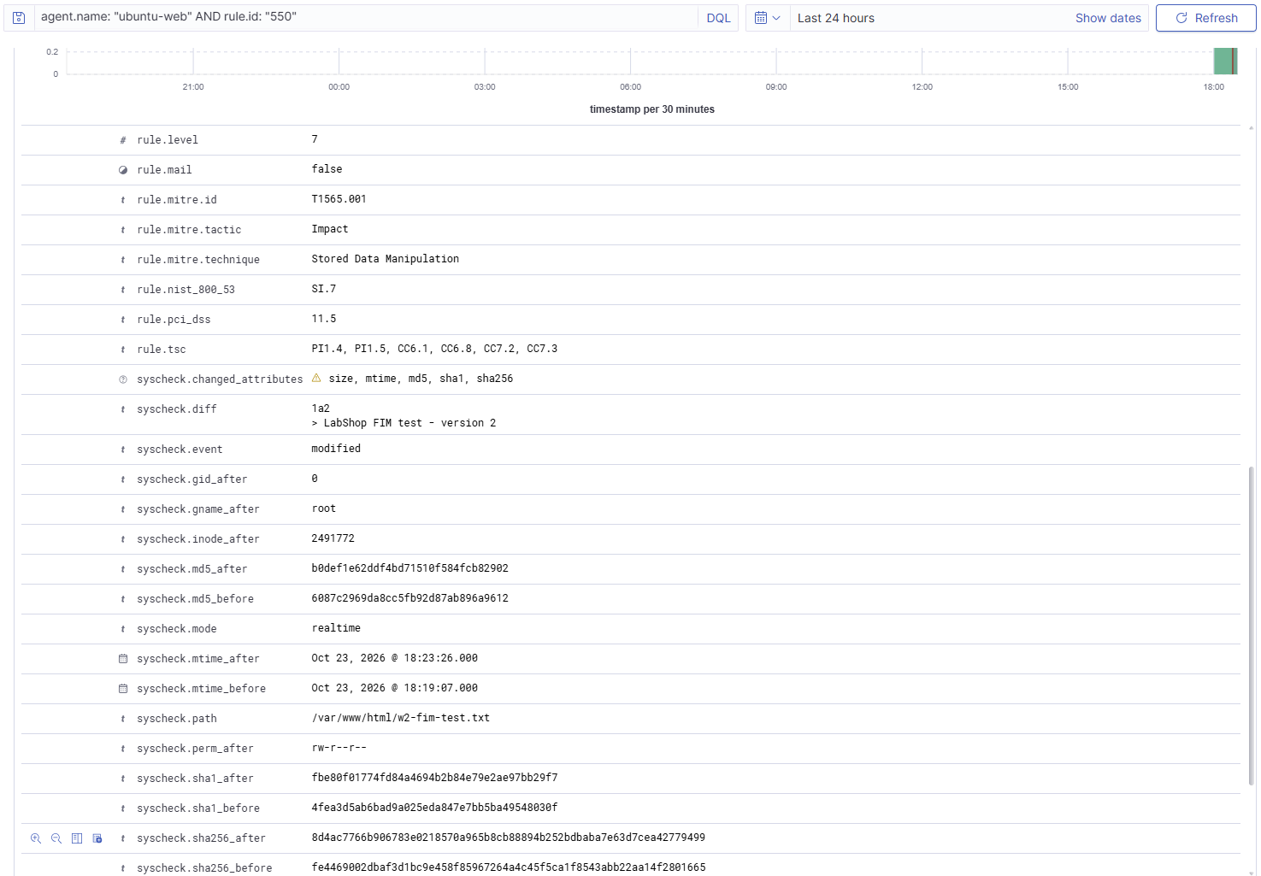
Figure 4. Linux real-time checksum change: rule 550 and file-content difference.
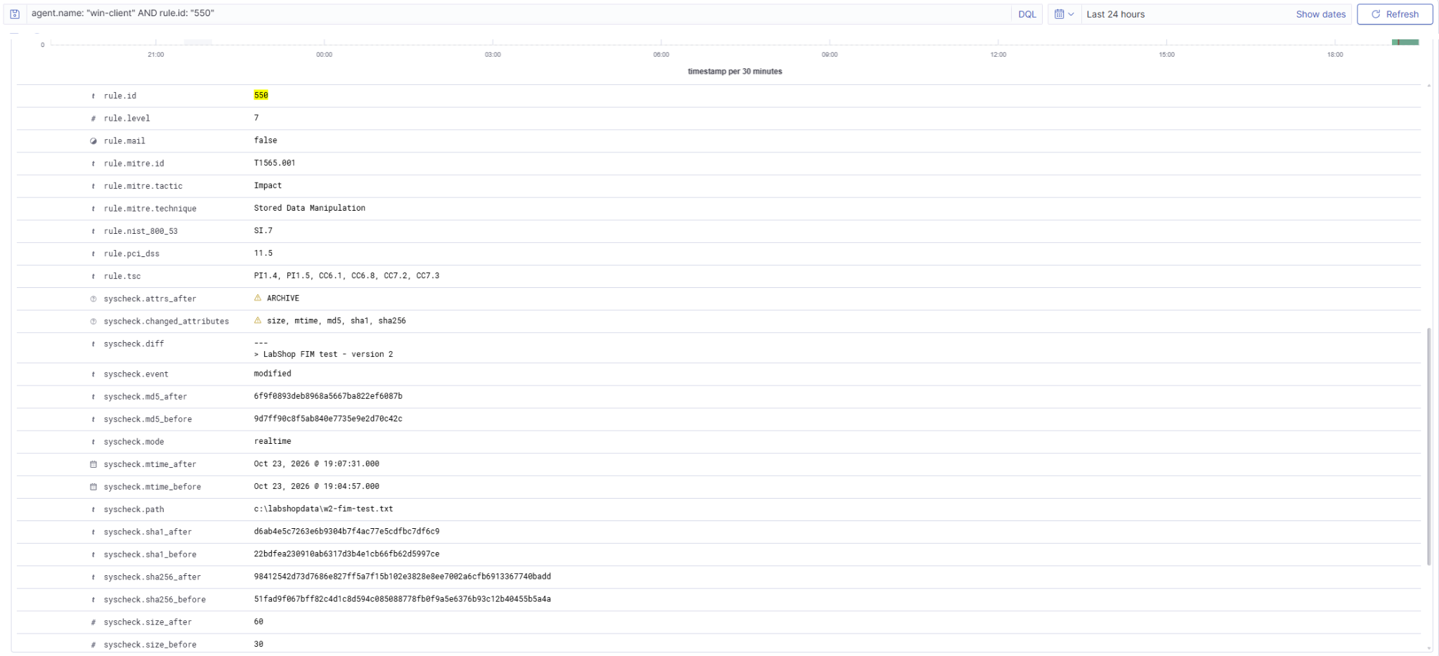
Figure 5. Windows file modification: Wazuh rule 550 with the changed LabShopData test file.
Creation and deletion have additional supporting Discover screenshots for both VMs (rules 554 and 553) and were retained in the original evidence collection; the representative modification images above demonstrate the richer diff information. All six transitions were observed as alerts rather than inferred from configured paths.

4.3 Windows registry value change
The HKLM\SOFTWARE\LabShop key contained a Status string. It was first set to Baseline and then changed to Modified. The relevant Wazuh event showed rule 750, “Registry Value Integrity Checksum Changed”, and syscheck.value_name=Status under the 64-bit registry view. The observed syscheck.mode was scheduled, confirming that the registry value was detected at scan time rather than immediately on write.
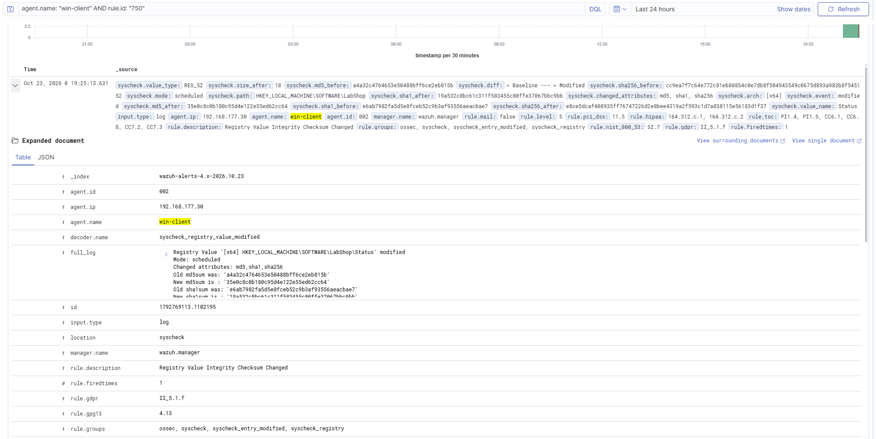
Figure 6. Windows registry change under HKLM\SOFTWARE\LabShop; Wazuh rule 750.

4.4 Real-time versus scheduled FIM timing
Mode / source | File change UTC | Alert UTC | Approx. latency
Linux realtime | 23 Oct 15:45:57 (mtime_after) | 23 Oct 15:45:57.267 | Same second (< 1 s at logged precision)
Windows realtime | 23 Oct 15:07:31 | 23 Oct 15:07:32.259 | 1.3 s
Linux scheduled /etc | 23 Oct 15:39:07.442 | 23 Oct 15:39:36.561 | 29.1 s

Timing interpretation. The Linux realtime event and its mtime_after field fall in the same displayed second, although the file timestamp has only one-second precision. The earlier mtime_before is the prior version timestamp and must not be used as the beginning of detection latency. The Windows realtime and Linux scheduled timings above are approximate event-to-alert intervals. Real-time monitoring generally improves detection latency, while scheduled monitoring has lower continuous watch overhead and delays detection until a scan.
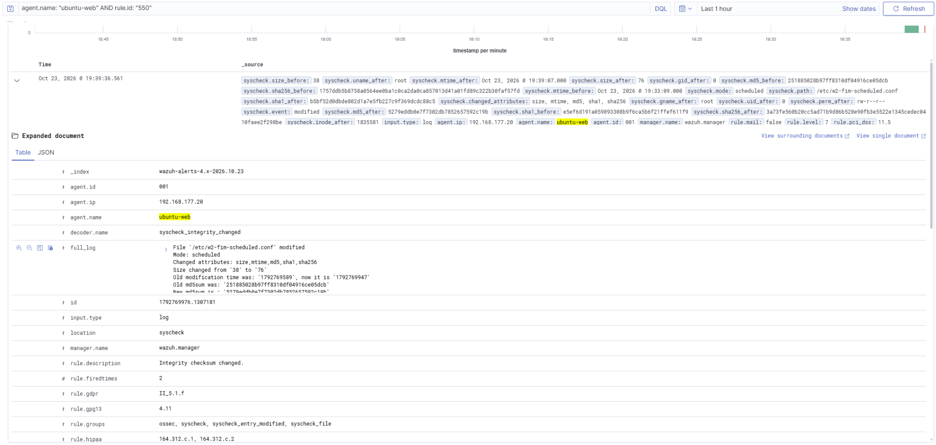
Figure 7. Scheduled Ubuntu FIM: /etc/w2-fim-scheduled.conf integrity alert after the scan.
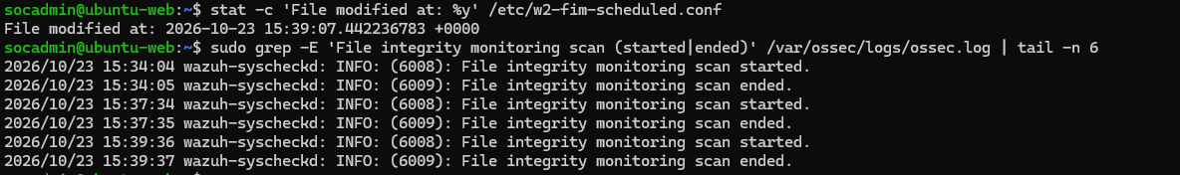
Figure 8. Endpoint scan log and file modification timestamp used for the scheduled timing calculation.

5. Task 3 — Suricata IDS and Wazuh integration

5.1 Installation, rules and network interface
Suricata 7.0.3 was installed on ubuntu-web after a temporary VMware NAT adapter was attached. Initial service launches failed because the packaged configuration still referenced non-existent eth0. On this VM, the host-only NIC is ens33. The af-packet interface was corrected to ens33, the local HOME_NET was scoped to 192.168.177.0/24, and an explicit /etc/suricata/rules/labshop.rules was loaded without large public rule sets to conserve the 2 GB VM memory.
alert http any any -> 192.168.177.20 80 (msg:"LABSHOP HTTP Admin URI Probe"; flow:established,to_server; http.uri; content:"/admin"; nocase; sid:1000001; rev:1;)
The command suricata -T -c /etc/suricata/suricata.yaml returned exit code 0, and the service was active with automatic start enabled. Suricata logged one signature processed and one successfully loaded. The final address and route output showed ens33 only with no default route after the NAT adapter was removed.

5.2 HTTP probe and EVE JSON
From the physical Windows 11 host (192.168.177.1), curl.exe -i http://192.168.177.20/admin returned HTTP 404. Suricata nevertheless recognized the HTTP request URI and generated SID 1000001 in /var/log/suricata/eve.json; application route existence is irrelevant to the signature. The EVE alert included src_ip=192.168.177.1, dest_ip=192.168.177.20, HTTP GET, URL=/admin, destination port 80, and the requested signature.
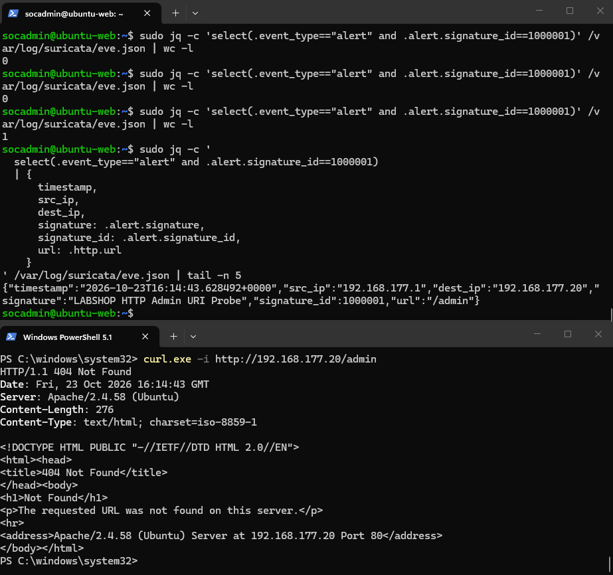
Figure 9. HTTP /admin test from the host and matching Suricata SID 1000001 in eve.json.

5.3 Wazuh parsing and severity escalation
The ubuntu-web Wazuh agent was configured to read /var/log/suricata/eve.json as JSON. The built-in Suricata rule 86601 recorded the alert at Wazuh level 3; the custom rule 100110 then matched the Suricata signature and raised it to level 10. The custom rule was verified with wazuh-logtest before the Manager service was restarted. This distinguishes the Suricata signature identifier 1000001 from Wazuh correlation rule identifier 100110.
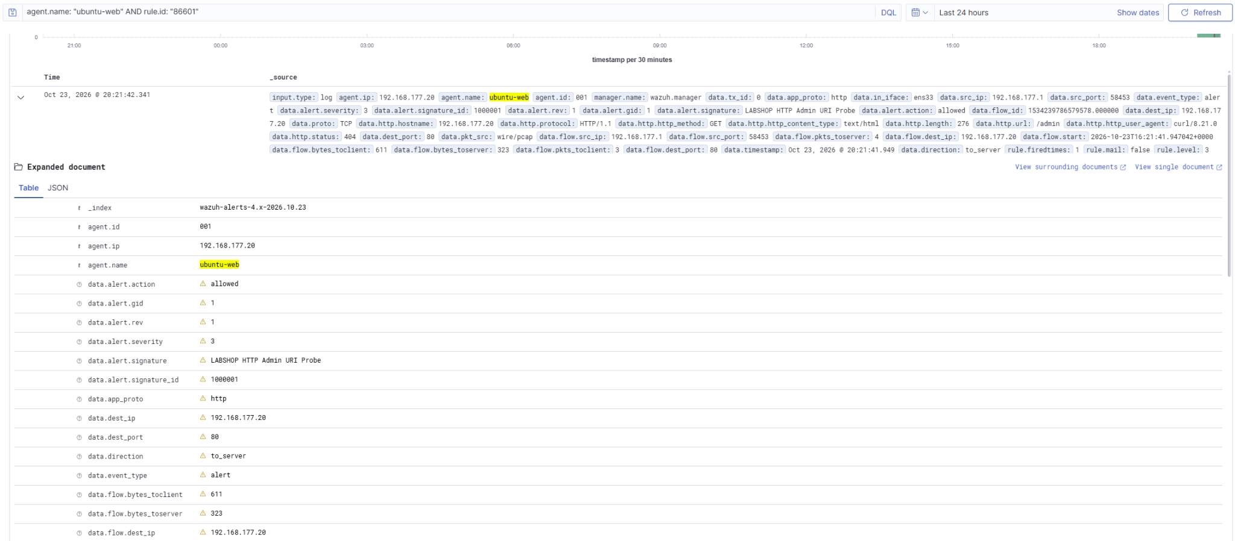
Figure 10. Initial Suricata alert in Wazuh under built-in rule 86601 (level 3).
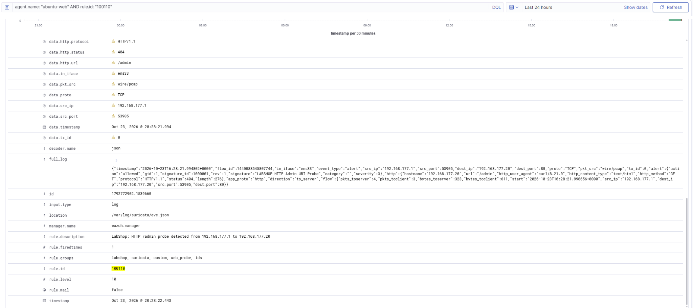
Figure 11. Custom Wazuh escalation: rule 100110, level 10, for the /admin probe.
The signature specifically checks the HTTP URI for /admin; a normal GET / does not satisfy its content test. The normal homepage negative-case outcome is recorded as expected behavior, but no separately preserved Wazuh negative-test screenshot is available for an independent absence count.

5.4 Isolation and resource limits
After installation, ubuntu-web again had only ens33 (192.168.177.20/24) and no default gateway. The wazuh-agent, suricata and apache2 services all reported active. Suricata memory usage was 45.3 MiB (45.5 MiB peak); guest memory showed 1.9 GiB total and 1.4 GiB available, with 0 GiB swap use at measurement time. This reflects a deliberately small single-signature IDS rather than a full production ruleset.

6. Task 4 — SCA and vulnerability assessment

6.1 Applied policies and measured outcomes
Endpoint / policy | Passed | Failed | N/A | Score
Ubuntu baseline — CIS Ubuntu Linux 24.04 LTS v1.0.0 | 112 | 125 | 42 | 47%
Ubuntu post-remediation — same policy | 121 | 116 | 42 | 51%
Windows — CIS Microsoft Windows 10 Enterprise v4.0.0 | 117 | 302 | 5 | 27%

Ubuntu passed counts increased by nine and failed counts fell by nine between the recorded policy scans. The two selected banner checks changed individually from Failed to Passed; other status changes occurred during reassessment, so the full nine-check delta must not be attributed solely to editing two files.
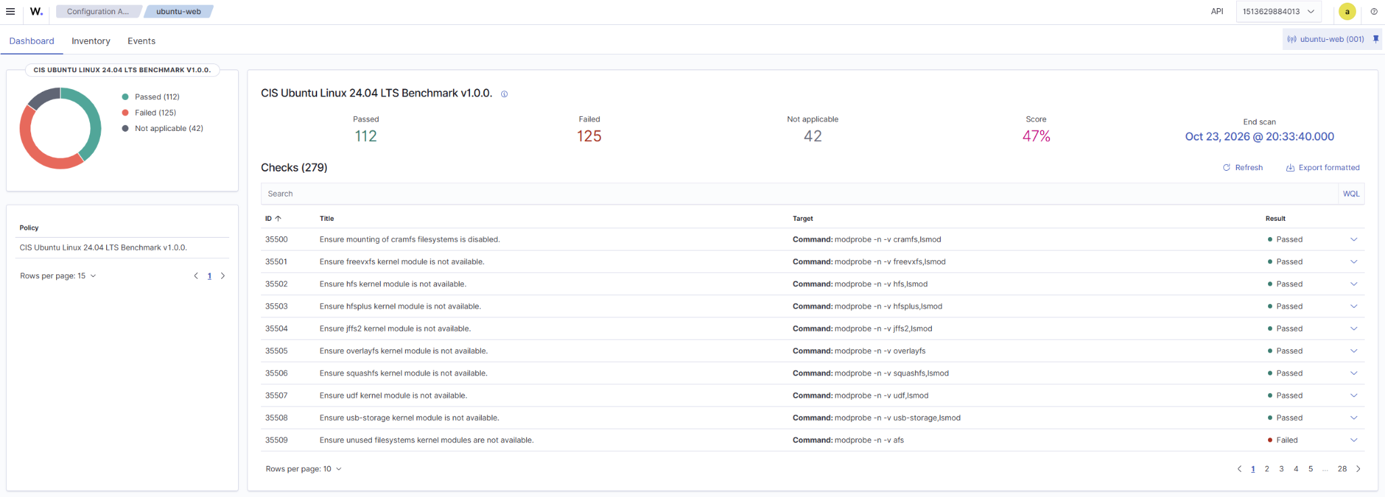
Figure 12. Initial Ubuntu CIS policy summary: 112 passed, 125 failed, 42 not applicable.
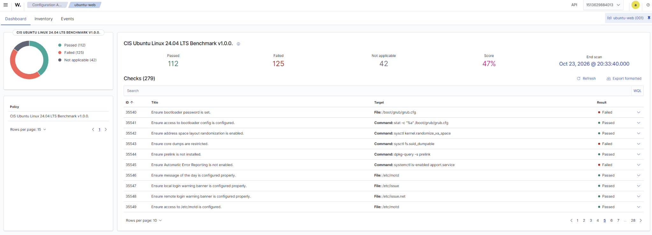
Figure 13. Post-remediation Ubuntu CIS policy summary: 121 passed, 116 failed, 42 not applicable.
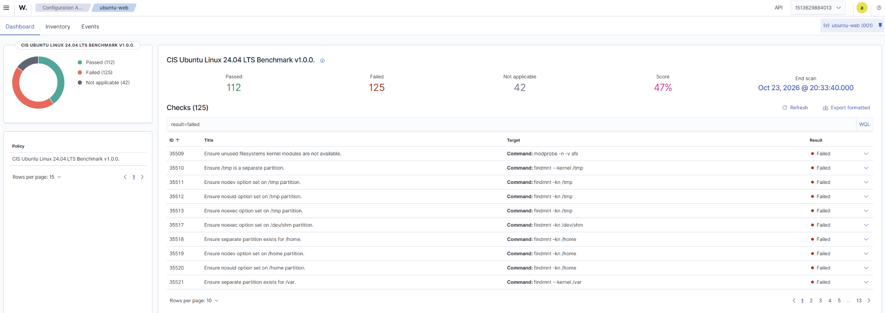
Figure 14. Windows CIS policy summary: 117 passed, 302 failed, 5 not applicable.

6.2 Two selected low-risk remediations
SCA check | Why the control matters | Action and result
35547 — /etc/issue | A local login notice discourages unauthorized use and supports access policy communications. | Configured an approved identification-neutral warning banner; after scan: Passed.
35548 — /etc/issue.net | Remote terminal notice establishes authorized-use expectations before sign-in. | Configured matching warning text; after scan: Passed.
Both files were checked for root ownership and 0644 permissions. Wazuh agent restart triggered an SCA scan and the individual controls became Passed. The chosen wording includes “Authorized users only”, prohibition of unauthorized access, and notice that activity may be monitored.

6.3 Deliberately unresolved finding and risk decision
Ubuntu check 35510 — “Ensure /tmp is a separate partition” — remained Failed. For Week 2 the finding was documented, not remediated.
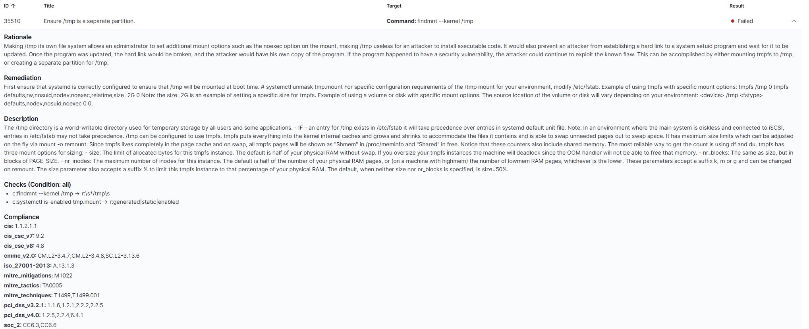
Figure 15. Documented non-remediation: CIS check 35510 and its /tmp isolation rationale.

6.4 Vulnerability detection — top three selected Critical findings per agent
Wazuh Vulnerability Detection inventoried 3,858 evaluated entries for ubuntu-web and 3,528 for win-client at the recorded observation point. The views included Ubuntu entries filtered to Critical and Windows records with Critical severity. The selected examples below each carry the Wazuh-displayed base scores.
Agent / affected package | CVE | CVSS | Fix available? / assessment
Ubuntu linux-image-6.8.0-146-generic | CVE-2026-74705 | 10.0 | Upstream kernel fix published; Ubuntu packaged fix for this exact install not independently established.
Ubuntu linux-image-6.8.0-146-generic | CVE-2026-74612 | 10.0 | Kernel issue has published fix context; matching Ubuntu package fix not independently established.
Ubuntu linux-image-6.8.0-146-generic | CVE-2026-63795 | 10.0 | Scanner states installed package < 6.8.0-147; newer version is indicated.
Windows 10 Enterprise Eval 19045.2006 | CVE-2026-57092 | 9.9 | Wazuh indicates a higher fixed-build threshold (19045.7548).
Windows 10 Enterprise Eval 19045.2006 | CVE-2025-49708 | 9.9 | Wazuh indicates newer-build threshold (19045.6456).
Windows 10 Enterprise Eval 19045.2006 | CVE-2026-96924 | 9.8 | Wazuh indicates newer-build threshold (19045.7807).

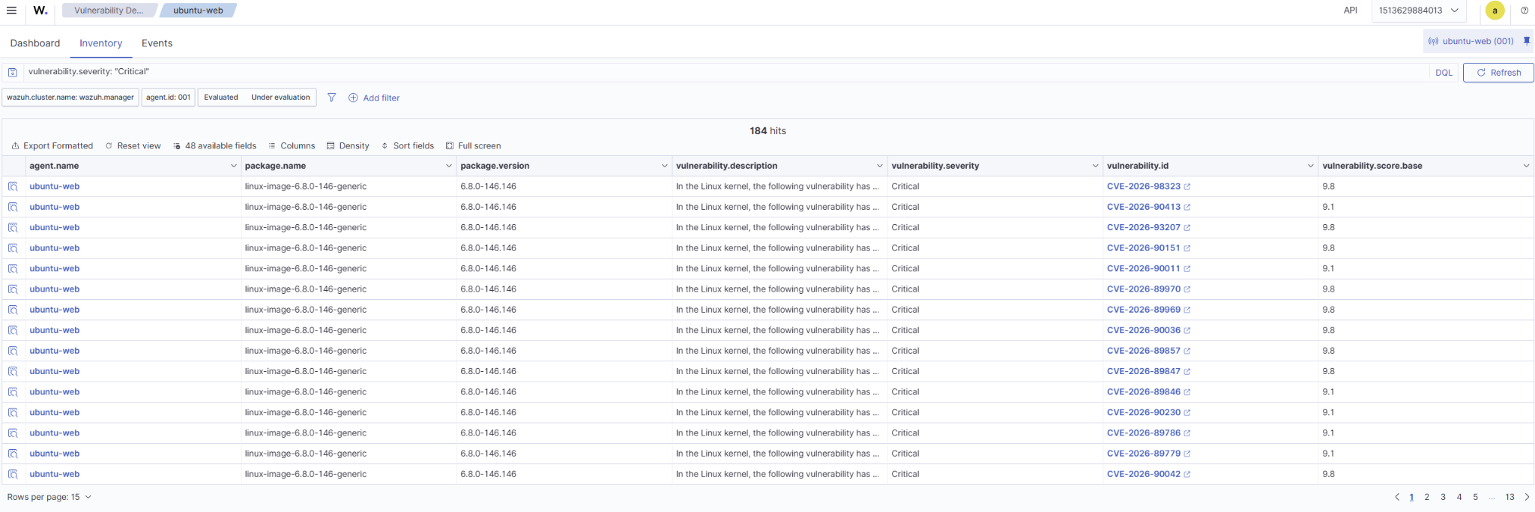
Figure 16. Ubuntu critical vulnerability inventory: kernel package, CVE IDs and CVSS scores.
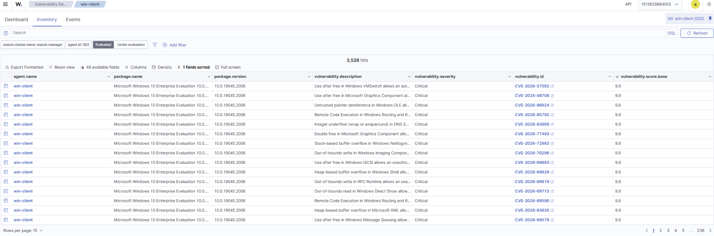
Figure 17. Windows critical vulnerability inventory showing the OS build and selected CVEs.

7. Task 5 — Documentation, backups and snapshots

7.1 Configuration backup inventory
Backup copies were preserved in ~/mini-soc-week2-backup on siem-host.
Backup / source | Purpose and required repository destination
decoders/100100-labshop_decoder.xml | Custom LabShop parent/child decoder → rules/
manager/rules/100101-labshop_rules.xml | Authentication event and brute-force correlation → rules/
manager/rules/100110-labshop_suricata.xml | Suricata severity escalation → rules/
ubuntu-web/suricata/labshop.rules | Local HTTP /admin IDS signature → evidence/week2/
ubuntu-web/suricata/suricata.yaml | Interface, HOME_NET, EVE and rule-path configuration → evidence/week2/
ubuntu-web/wazuh/ossec.conf | App log, Suricata EVE and Ubuntu FIM → evidence/week2/
win-client/ossec.conf | Windows file and registry monitoring → evidence/week2/

7.2 VMware recovery points and service validation
Each VM has w2-start and w2-done VMware snapshots; the final snapshots were captured after normal shutdown. The Manager/Indexer/Dashboard containers were Up before shutdown, Suricata, Wazuh Agent and Apache were active on Ubuntu, and WazuhSvc was Running on Windows. The w2-done snapshot provides a reproducible post-Week-2 restoration point.
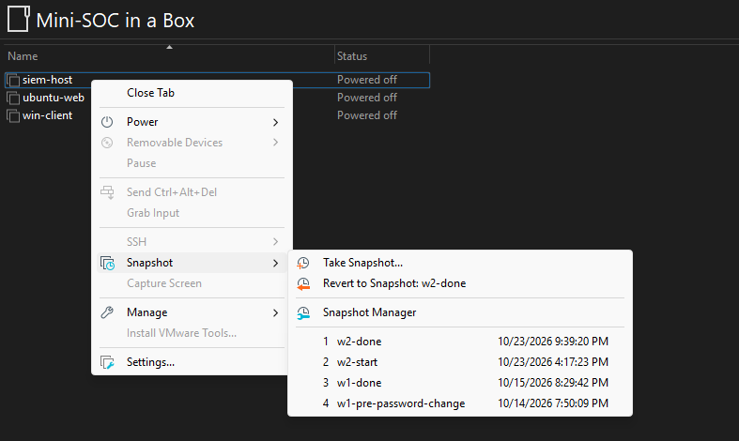
Figure 18. siem-host snapshot chain showing w2-start and w2-done.
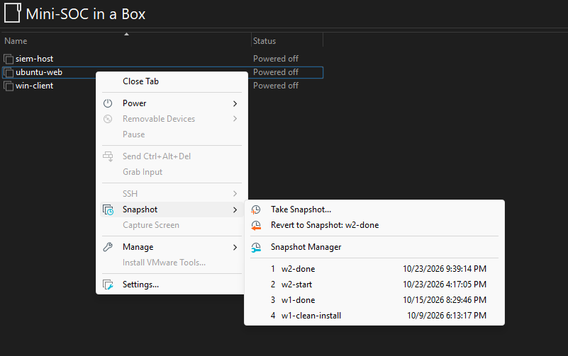
Figure 19. ubuntu-web snapshot chain showing w2-start and w2-done.
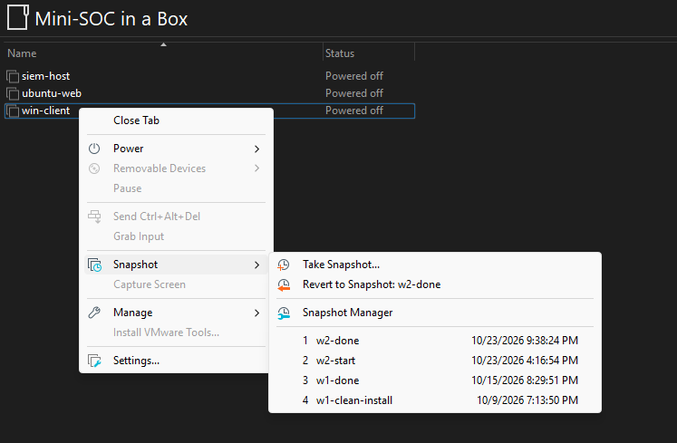
Figure 20. win-client snapshot chain showing w2-start and w2-done.

7.3 Restore procedure and source-control checklist
Restoration starts with a snapshot or backup and validates syntax before enabling the service. On siem-host, place decoder XML in the persistent /var/ossec/etc/decoders and custom rule XML in /var/ossec/etc/rules as exposed by the Wazuh Manager Compose volumes; use wazuh-analysisd -t inside the container to verify the rules. Restart only the required Manager service or container and rerun the known login and /admin tests. On ubuntu-web restore Suricata YAML, labshop.rules and ossec.conf, run suricata -T, then restart Suricata and the Wazuh agent; on Windows restore ossec.conf and restart WazuhSvc.

8. Troubleshooting, tuning and limitations
Issue / observed symptom | Resolution or documented trade-off
Suricata did not start: af-packet eth0 no such device | Changed capture interface to ens33; suricata -T passed and service active.
No Suricata signatures loaded | Set rule-files to /etc/suricata/rules/labshop.rules; confirmed one loaded signature.
Windows registry alert not immediate | Verified registry was scheduled; temporarily shortened interval, restarted agent, restored default frequency.
Ubuntu FIM scan frequency remained at 43200 | Identified active <syscheck> frequency and restarted agent; log confirmed 120-second test frequency, later reverted.
Custom wrong-format log had no LabShop alert | Decoder required valid dotted-quad src IP; Wazuh emitted generic fallback rule 1002.
CIS hardening could affect availability | Selected low-risk /etc/issue banner changes; deferred /tmp filesystem restructuring.
Potentially noisy detection | Rule 100101 on every failed login could flood alerts; tune allowlists/rate limits and preserve brute-force correlation.

9. Conclusion
Week 2 delivered a functioning custom-detection pipeline for LabShop, verified FIM across two operating systems, a monitored Windows registry key, a purpose-built Suricata /admin signature forwarded into Wazuh, and an initial CIS/vulnerability baseline. Custom backups and w2-done snapshots taken.

Change journal and rollback reference
Milestone | Change / purpose | Rollback
1. LabShop ingestion | Added /var/log/labshop/app.log localfile to ubuntu-web ossec.conf. | Restore backed-up ossec.conf; restart Wazuh agent.
2. Decoder and rules | Added parent/child parser and L5/L10 failed-login detections; suppressed monitor. | Restore saved custom XML; validate; restart Manager.
3. Endpoint FIM | Added realtime web root and C:\LabShopData watches; enabled report_changes. | Restore agent ossec.conf; restart agent.
4. Registry FIM | Created HKLM\SOFTWARE\LabShop Status, enabled 64-bit scheduled watch. | Restore registry/config backups; remove test key only if safe.
5. Timed scan test | Temporarily shortened Ubuntu FIM scan interval to 120 seconds. | Restored baseline 43200 seconds; restart agent.
6. Suricata capture | Installed Suricata, corrected eth0→ens33, scoped HOME_NET and local rule. | Restore suricata.yaml/rules; disable service if required.
7. Suricata into Wazuh | Added EVE JSON localfile and Manager escalation rule 100110. | Restore ossec.conf/XML backups; validate and restart.
8. SCA banners | Replaced /etc/issue and /etc/issue.net with authorized-use notices. | Restore files from OS backup or tracked baseline text.
9. Recovery point | Verified health and created w2-done snapshots on all three VMs. | Revert to w2-start or documented earlier checkpoint if needed.

